**EMS API DOCUMENTATION**

The API provides endpoints for user registration, authentication, event management, ticket booking, and notifications.

**BASE URL :** [**http://localhost:8000/**](http://localhost:8000/)

You can replace base url with your actual url

**BASIC-ENDPOINTS**

1. User Registration

URL: /register/

Method: POST

Description: Register a new user. **You can choose to be organizer or a participant during registration**

Request Body:

{

"username": "string",

"email": "string",

"password": "string",

"role": "string" // Optional: 'organizer' or 'participant'

}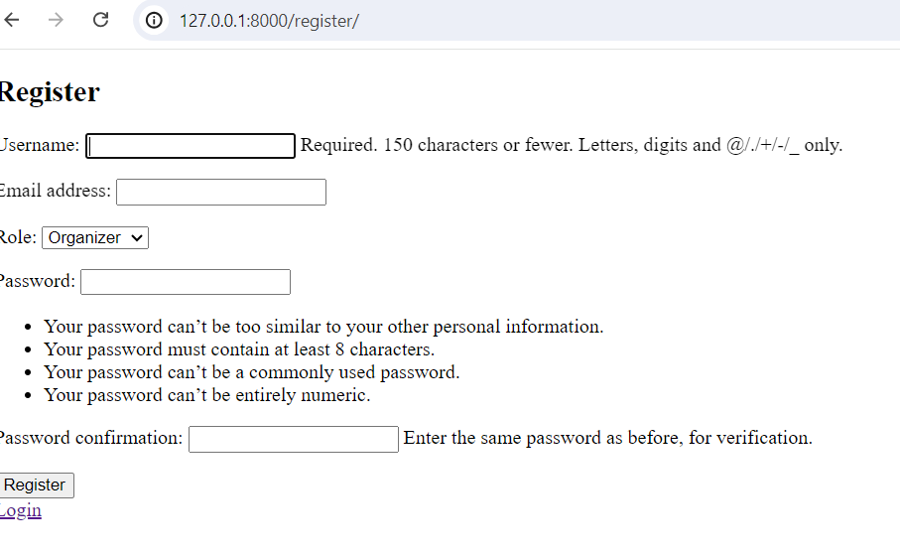

2. User Login

URL: /login/

Method: POST

Description: Authenticate and login a user

Request Body:

{

"username": "string",

"password": "string"

}

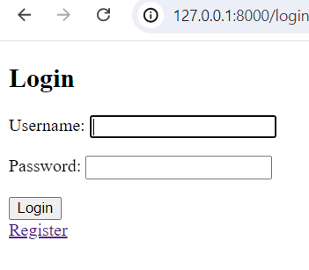

3. User Logout

URL: /logout/

Method: GET

Description: Logout the current user

4. Events list and create

URL: /api/events

Method: GET, POST

Description: List all events or create a new event [ **Role: Organizer** can view events as well as create events, **Role: Participant** can only view events

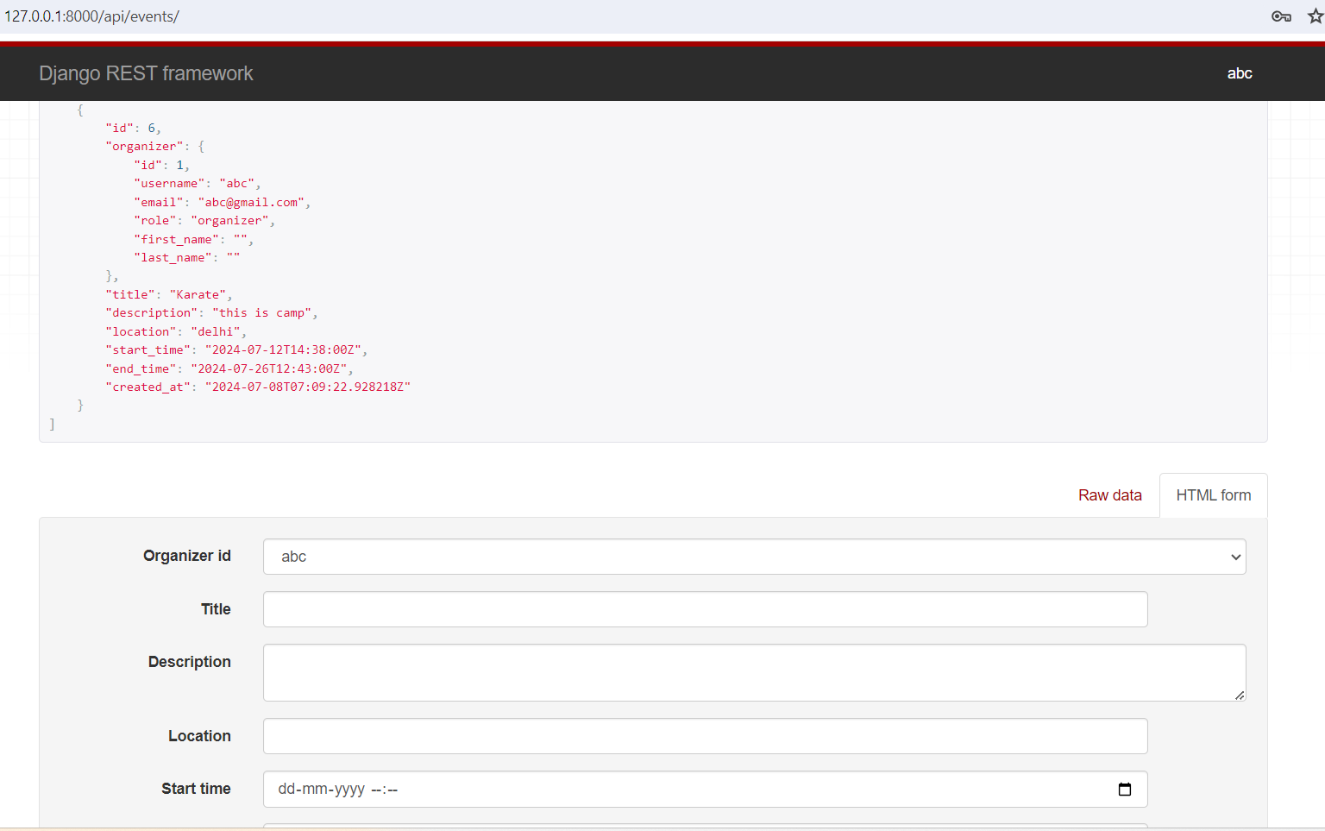

[ORGANISER can view events as well as create them]

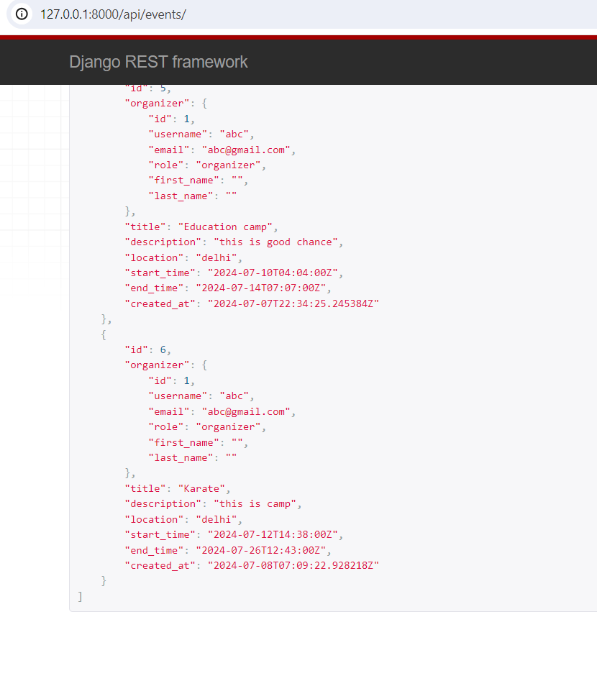

[PARTICIPANT can only view events]

5. Event Update, Detail and delete

URL: /api/events/<int:pk>

Method: GET, PUT,DELETE

Description: Retrieve, update, or delete a specific event by ID. [Only organiser is permitted for CRUD operations]

RESPONSE: Returns the event details or confirmation of deletion.

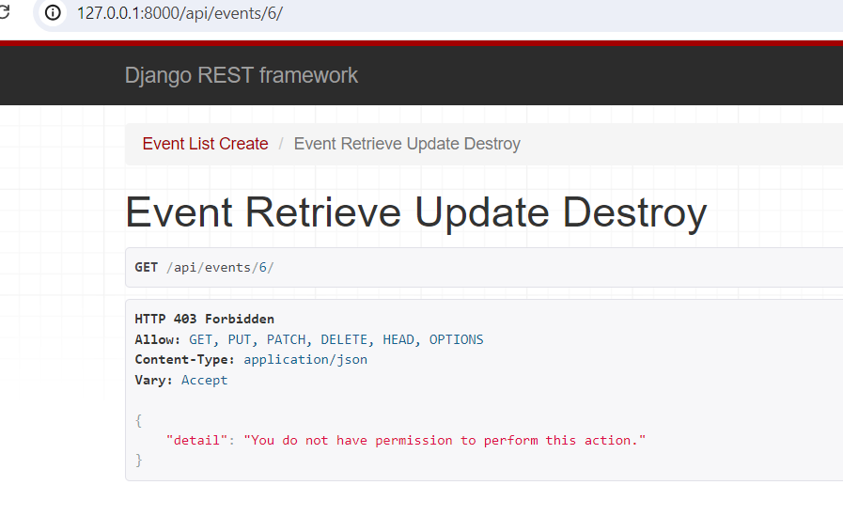

[Participant not allowed to perform crud operations]

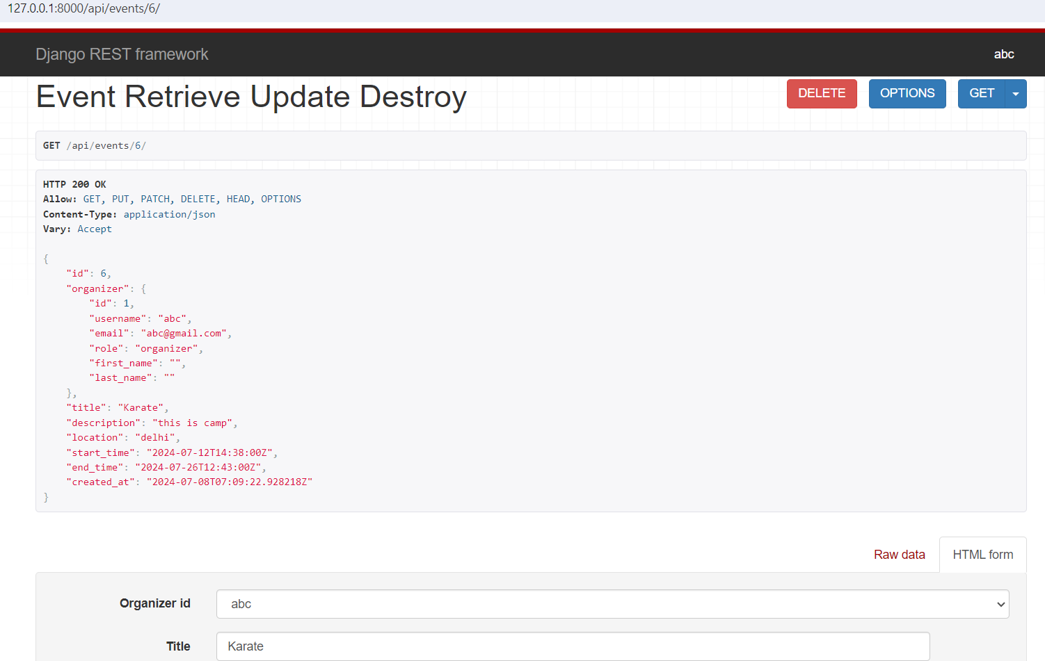

[Organiser allowed for CRUD operations]

6. Book ticket for an event

URL: /api/events/<int:event_pk>/book/

Method: POST

Description: Book a ticket for a specific event

RESPONSE: Returns confirmation of ticket booking.

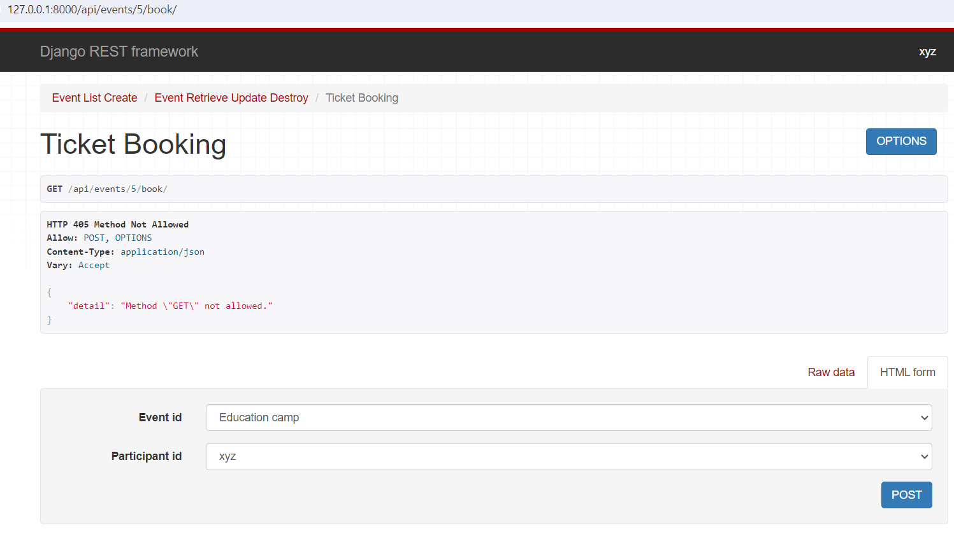

[Participant can book ticket]

7. List Notificaitons

URL: /api/notifications/

Method: GET

Description: List all notifications for the current user

RESPONSE: Returns a list of all notifications

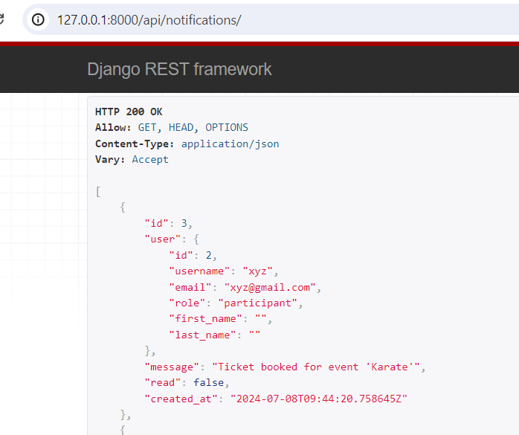

8. Update notifications and read status

URL: /api/notifications/<int: pk>

Method: PUT

Description: Update the read status of notification

RESPONSE: Returns confirmation of notification read status update.

